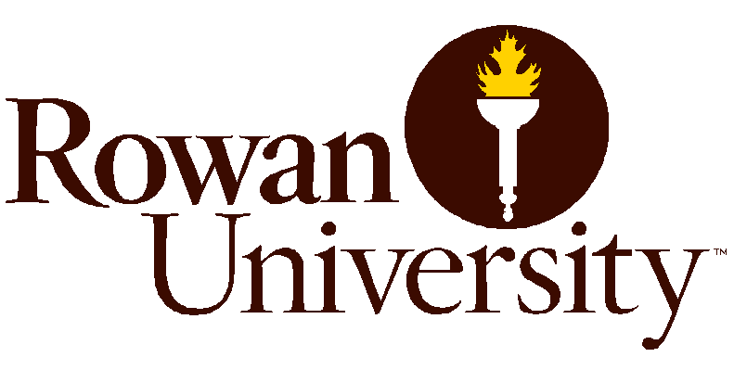
“Review of the Open Public Records Act (OPRA) and Family Educational Rights and Privacy Act (FERPA) for College and University Employees”
Monday, October 2, 2017
Rowan University
Chamberlin Student Center Room 221
201 Mullica Hill Road
Glassboro, NJ 08028

10:00 AM -10:30 AM - Sign- In & Networking
10:30 AM- 12:30 PM - Presenter: Joseph Glover, Executive Director- New Jersey Government Records Council (GRC)
This seminar will assist College and University employees to better understand the mandatory requirements of the Open Public Records Act (OPRA), as well as cover recent rulings by the Government Records Council and NJ Superior Court that affect the disclosure of government records. Topics discussed will include:
-An overview of OPRA
-An overview of the GRC’s function and services provided to requesters and records custodians
-Discussion of common OPRA issues/exemptions and how they impact a custodian’s response to a request
- Discussion of common OPRA issues regarding New Jersey Colleges and Universities
- Question & Answer session
12:30 PM – 1:00 PM -Lunch
1:00 PM - 3:00 PM- Presenter: Valdoston Shealey, General Counsel- Rowan University
Rowan University Assistant General Counsel will assist participants with understanding the Family Educational Rights & Privacy Act (FERPA) Act rules and requirements.

“Review of the Open Public Records Act (OPRA) and Family Educational Rights and Privacy Act (FERPA) for College and University Employees”

Registration Form

First Name:

Last Name: Click here to enter text.

Title: Click here to enter text.

Email: Click here to enter text.

School/ Institution: Click here to enter text.

Submit registration form to opra@rowan.edu
Parking is available at the Townhouse Garage Level 3
Please come to the main welcome gate and the guard will direct you.
For questions please contact the Contracting & Procurement Office at 856-256-5172
For more information about Rowan Universities Open Public Records policy please visit our website at: Rowan University- OPRA/FERPA

